**Prepare Labor Claims Workbook Work Instructions**

1. Open EVMS Labor Processing (Ben Trubie tool) from desktop – see below.
   1. 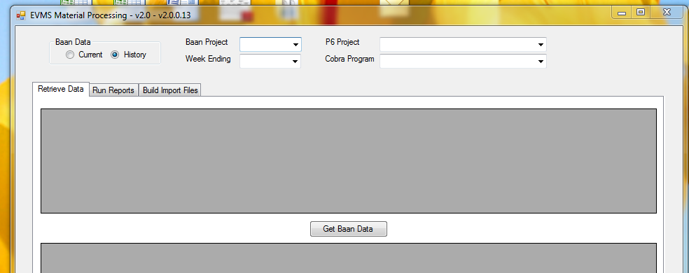
   2. Once this is opened, enter the project number needed:
      1. Example: LCS 5 – Enter 0466
      2. Example: LCS 7 – Enter 0468
   3. Click the drop down box to find the current reporting period month end.
      1. Example: August 2016 – Click drop down for 8/27/2016.
      2. Click the appropriate date.
   4. In the ‘Retrieve Data’ screen tab, click Get Baan Data.